Qualification Testing Test Completion Report <organisation>

Document owner | Document number | Version
Non-SIT S&A Team | MHHS-DEL3381 | V1.0
Status: | Date | Classification
Final | 14-Jan-2025 | Public



Document owner | Document number | Date

- Contents
1. Contents 1
1.1 Programme Participant Name 3
1.2 Change Record 3
1.3 Document Approval 3
1.4 References 3
1.5 Terminology 3
2 Introduction 4
3 QT Testing 4
3.1 QT Testing Summary 4
Final Overall Execution Status 4
3.2 QT Testing Test Cases Planned vs Actual 6
3.3 QT Testing Defect Summary 6
3.3.1 Summary of Defects Raised by Severity 6
3.3.2 Summary of Defects by Priority 6
3.3.3 Summary of Open Defects 7
3.4 QT Testing Work Off-Plan 0
4 Exit Criteria Assessment 1
5 Overall Risk Assessment 2
APPENDIX A – 3
Please provide any supplementary sections to this document as required. 3

List of Figures
Figure 1: Overall QT Test Execution 5

Guidance notes:
Participant are expected to use this template for documenting their QT Test Completion Report (TCR). All Qualification Testing must be covered. Programme participants can also add any additional sections as they feel appropriate. If a participant is completing testing for more than one role, they can either add additional sections to cover each role tested or submit separate TCR.

Red text indicates guidelines or examples.

Template starts from Page 3 onwards - this page can be removed from the final document produced by Programme participants

Programme Participant Name
Programme participants to fill in the table below and include their relevant constituency group and third-party provider if applicable for each role.
Programme Participant Name and Role | Constituency Group | MPID(s) Tested | Third Party Provider
e.g. Generic Electricity Co. Ltd / Supplier | I&C Supplier | MPID(s) | N/A

Change Record
The table below needs to be updated with details of each amendment and change control.
Date | Author | Version | Change Detail

Document Approval
The table below needs to be updated and the role needs to be defined per person as one of the following categories:
- Review;
- For Information;
- For Approval; and
- Approval and Sign Off.
Reviewer/Approver | Role

References
Reference any documents into the table below along with reference and version number. Programme participants should insert documents wherever possible. If multiple roles are being tested, please ensure the appropriate documentation is included for each role where distinct.
Reference | Documents | Publisher | Version | Additional Information
REF 001 | Qualification Test Plan
REF 002 | Requirements to Test Traceability Matrix
REF 003 | Final QTC Test Set

Terminology
Reference any terminology used in this document.
Term | Description

Introduction
This section should set out the way Programme participants conducted testing during all test stages within the QT test phases of the MHHS programme.

The objective of the Test Execution Completion Report is to provide a complete report of Qualification Testing (QT) for the MHHS solution as tested by <Name of participant> for <roles>:

- To provide information on defects identified during QT test phase and any outstanding defects and
- To provide enough information for Code Bodies to instil confidence that testing has been carried out to a sufficient quality to meet QT exit criteria in accordance with the Non-SIT S&A Qualification Approach and Plan.

QT Testing

QT Testing Summary
Your testing summary is declared via the Final QTC Test Set which outlines all tests that have been included for Qualification Testing. If multiple sets have been used (more than one role test), please ensure all sets are provided and referenced in this section.
Reference | Documents | Publisher | Version | Additional Information
REF 001 | e.g. QTC Set for MPID/ROLE
REF 002
REF 003

Final Overall Execution Status
This section should detail all the summaries of the final overall execution statuses for each of the test cycles that were part of the QT testing. The summary should list the number of tests which are passed, failed, blocked, to do, de-scoped and in progress status. Please note that Participants are expected to pass all tests therefore any failed, blocked or de-scoped tests must be agreed in advance via work-off plan with the Code Bodies.

Test Activity
This section should provide a screenshot of the overall execution status from your QTF dashboard. Please include one dashboard capture for each role tested.
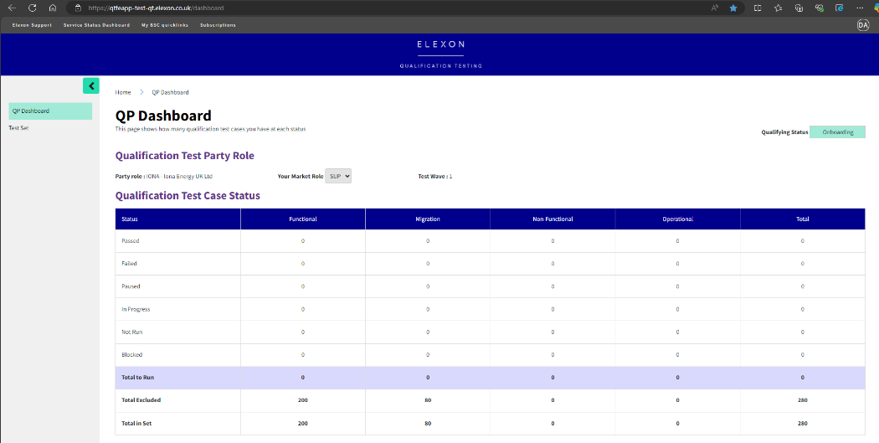
Example
Figure 1: Overall QT Test Execution

Test Area | Passed | Failed | Blocked | To Do | De-Scoped
<test phase or other grouping of tests>
Total | 19 | 2 | 1 | 2 | 0
Table 1: Overall Test Execution Status
This section should provide commentary on tests (or groups of tests) which failed, remain blocked or are outstanding. It is expected that all Participants shall complete all tests therefore should any tests not be passed, this must be subject to a work-off plan agreed with the Code Bodies.

QT Testing Test Cases Planned vs Actual
If any tests have been de-scoped during Qualification Testing, please declare these here and provide any correspondence from Code Bodies agreeing to these exclusions.
QTC Case ID | Description of Test | Rationale for De-Scoping
QT-001 | Change of DS Advanced Linked | Agreed with Code Bodies to de-scope as not included in business flows
 | `

Table 2: De-scope Test Cases

QT Testing Defect Summary
If any defects remain open following Qualification Testing, please declare these here and provide any correspondence from Code Bodies agreeing to these remaining defects.

Summary of Defects Raised by Severity
This section should describe the summary of defects raised by severity:
Severity | Number of Defects | Outstanding Defects
S1 - Critical | 4 | 0
S2-Major/High | 2 | 0
S3-Medium | 212 | 5
S4-Low | 50 | 1
Total | 280 | 7
Table 3: Summary of Defects Raised by Severity

Summary of Defects by Priority
This section should describe the overall summary of defects by priority:
Priority | Number of Defects | Outstanding Defects
P1 - Critical | 40
P2 – Major/High | 60
P3 – Medium | 80
P4 – Low | 80
Total | 280
Table 4: Summary of Defects raised by Priority

Summary of Open Defects
This section should describe the summary of all open Defects within QT testing :
Defect ID | Test Type | Description | Priority | Severity | Impact to Operations | Impact to Settlement  /Retail Risk | Proposed Workaround
Table 5: Summary of Open Defects

QT Testing Work Off-Plan
If all testing cannot be completed, a work-off plan must be discussed, created and agreed with the Code Bodies. Please reference the work-off plan(s) here if required. Note that a work-off plan template must be requested from the Code Bodies.
Reference | Documents | Publisher | Version | Additional Information
REF 001 | e.g. Work-Off Plan for MPID/ROLE
REF 002
REF 003
Table 6: Work-off Plan references

Exit Criteria Assessment
Exit Criteria | RAG Status | Status/Next Steps | Evidence
No outstanding Severity 1 and Severity 2 Defects.  • | Complete | Achieved | Appendix A
Sev3 and Sev4 defects that cannot be resolved during QT are documented with impacts assessment and a work off plan by the Programme Participant, reviewed by the Non-SIT S&A QT Team and agreed with Code Bodies ahead of QT completion. |  | See work off plan
100% test execution coverage, including functional, non-functional, migration and operational testing with approval from Code Bodies for any de-scoped/ failed test cases prior to QT completion.

Non-SIT S&A QT Completion Report including work off reviewed by Non-SIT S&A QT Team and submitted to Code Bodies
Test results and evidence has been captured in the QTF and has been assured by Non-SIT S&A QT Test Team.

Completion of any PIT work-off plans or deferred PIT activity (as agreed with Code Bodies)
Table 7: QT Exit Criteria Detailed Assessment

Overall Risk Assessment
This section will describe any risks which have been identified and agreed with the Code Bodies as highlighted during the outcome of the assurance process:

RAID No | Risk Summary | Severity | Mitigation | Status
Table 8: Risks Assessment

APPENDIX A –

Please provide any supplementary sections to this document as required.

